Additional Resources

Support Groups
Support groups are peer-led groups that offer nonjudgmental understanding from others who are experiencing similar struggles. They are facilitated by peers, not mental health professionals, and therefore are oriented towards support rather than treatment intervention. Such groups are often helpful not only for persons with lived experiences but also for their family members.

- Hearing Voices - Twin Cities https://hearingvoicestwincities.org/
- Hearing Voices Network (national) http://www.hearingvoicesusa.org/

Waiver Services
Disability Hub MN is a great resource for learning more about options to support one’s independent living in the community. Information about waiver programs, self-directed services, health insurance programs, and housing stabilization can be found at https://disabilityhubmn.org/

State Ombudsman
The mental health ombudsman is a person appointed as a 3rd party in complaints of maltreatment, particularly regarding services received by mental health treatment providers or organizations. If you or a loved one has been unjustly or unethically treated while receiving mental health services, or while attempting to access mental health services, reach out to the state ombudsman. Contact information can be found at this webpage: https://mn.gov/omhdd/

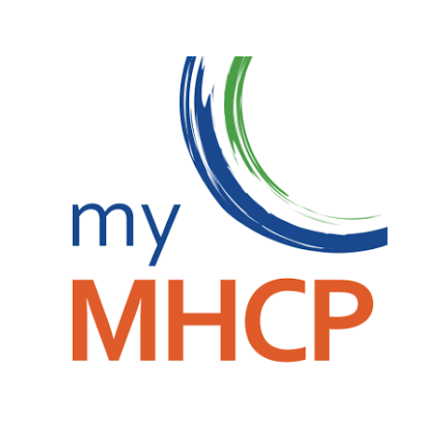
Smartphone Apps
- My Mental Health Crisis Plan (MHCP) is an app for creating a psychiatric advance directive. The app is free and can be downloaded in Google or Apple app store.

